Suman Deka
Email id: dekasuman3385@gmail.com
Address:Jalukbari(Bakul-path) Guwahati
Mob No.: +91-9854718628

Objective:

To work in a competent environment in an organization, where my full potential and talent is recognized and utilized to contribute in the overall growth of organization.
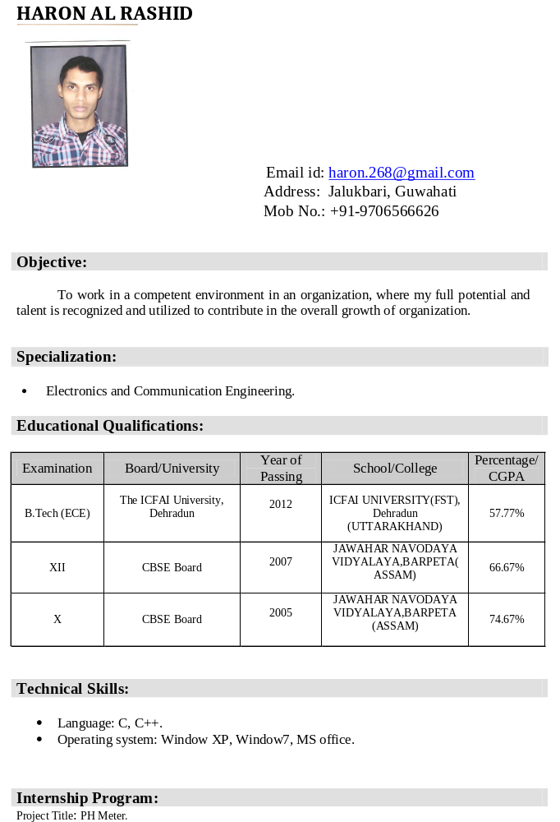

Specialization:

- B.com(Apeard)

Educational Qualifications:

Examination | Board/University | Year of Passing | School/College | Percentage/ CGPA
XII | SEBA Board | 2011 | PASHIM GUWAHATI MAHAVIDHALAYA | 49%
X | SEBA Board | 2013 | GOTANAGAR NAMBARI HIGH SCHOOL | 50.5%

Technical Skills:

- Language:DCA(Apeard) .

WORK EXPERIENCE- Fresher

Personal Profile

Father’s Name : Krishna kanta Deka
Mother’s name : Mina Deka
Date of Birth : 3March, 1995
Gender/Marital Status : Male/Single
Nationality : Indian
Mobile No. : +91- 9854718628
Permanent Address : Athgaon, Dist. - Kamrup, Assam (781123)
Language Known : Assamese, Hindi, English

Declaration:

I hereby state that the information stated above is correct to best of my knowledge and belief.

Place: Guwahati SUMAN DEKA

